Q&A Activity Question Week -13

Create a table as given below in MySQL. And write queries for the given statements.

| Employee ID | Name | Gender | Department | Salary | DOB | Date of Joining |
| --- | --- | --- | --- | --- | --- | --- |
| CP0123 | Ann Mery | F | HR | 45000 | 10/Oct/1  989 | 1/Jan/20  18 |
| CP0087 | Felix M | M | Finance | 48000 | 12/Apr/1  981 | 10/Dec/2  000 |
| CP0197 | Merlin | M | CEO | 80000 | 01/Mar/1  990 | 10/May/  2011 |
| CP0213 | Philip | M | Retail | 47000 | 01/Apr/1  991 | 11/June/ 2012 |
| CP0243 | Michael | M | Retail | 40000 | 01/Dec/1  992 | 30/May/  2016 |
| CP0289 | Susan | F | Retail | 40000 | 01/Jan/1  991 | 01/Apr/2  016 |
| CP0298 | Abram | M | Relations | 30000 | 17/Apr/1  994 | 06/OCt/2  016 |
| CP0300 | Alia | F | Relations | 30000 | 17/Oct/1  995 | 18/OCt/2  016 |
| CP0321 | Raichal | F | Marketing | 34000 | 09/Oct/1  990 | 22/OCt/2  016 |
| CP0276 | Thomas | M | Marketing | 44000 | 19/Nov/1  983 | 22/OCt/2  018 |

1. Write SQL queries to create the above table.

– Creating a database –

CREATE DATABASE company_db;

– Display the databases –

SHOW DATABASES;

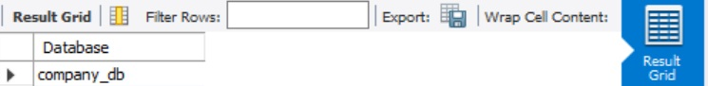

– Selecting a database –

USE company_db;

– creating a table –

CREATE TABLE Employees (

EmployeeID VARCHAR(10) NOT NULL PRIMARY KEY,

Name VARCHAR(20), Gender CHAR(5) NOT NULL,

Department VARCHAR(20) NOT NULL, Salary DECIMAL NOT NULL,

DOB DATE NOT NULL, Date_of_Joining DATE NOT NULL);

– Display the Structure of the table –

DESCRIBE Employees;

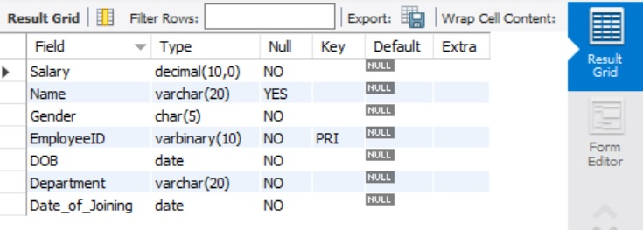

– Insert the values into the table –

INSERT INTO Employees( EmployeeID,Name,Gender,Department,Salary,DOB,Date_of_Joining) VALUES ('CP0123','Ann Mery','F','HR',45000,STR_TO_DATE('10/Oct/1989', '%d/%M/%Y'),STR_TO_DATE('1/Jan/2018', '%d/%M/%Y')), ('CP0087', 'Felix','M','Finance',48000,STR_TO_DATE('12/Apr/1981', '%d/%M/%Y'),STR_TO_DATE('10/Dec/2000', '%d/%M/%Y')), ('CP0197', 'Merlin','M','CEO',80000,STR_TO_DATE('01/Mar/1990', '%d/%M/%Y'),STR_TO_DATE('10/May/2011', '%d/%M/%Y')), ('CP0213', 'Philip','M','Retail',47000,STR_TO_DATE('01/Apr/1991', '%d/%M/%Y'),STR_TO_DATE('11/June/2012', '%d/%M/%Y')), ('CP0243', 'Michael','M','Retail',40000,STR_TO_DATE('01/Dec/1992', '%d/%M/%Y'),STR_TO_DATE('30/May/2016', '%d/%M/%Y')), ('CP0289', 'Susan','F','Retail',40000,STR_TO_DATE('01/Jan/1991', '%d/%M/%Y'),STR_TO_DATE('01/Apr/2016', '%d/%M/%Y')), ('CP0298', 'Abram','M','Relations',30000,STR_TO_DATE('17/Apr/1994', '%d/%M/%Y'),STR_TO_DATE('06/Oct/2016', '%d/%M/%Y')), ('CP0300', 'Alia','F','Relations',30000,STR_TO_DATE('17/Oct/1995', '%d/%M/%Y'),STR_TO_DATE('06/Oct/2016', '%d/%M/%Y')), ('CP0321', 'Raichal','F','Marketing',34000,STR_TO_DATE('09/Oct/1990', '%d/%M/%Y'),STR_TO_DATE('22/Oct/2016', '%d/%M/%Y')), ('CP0276', 'Thomas','M','Marketing',44000,STR_TO_DATE('19/Nov/1983', '%d/%M/%Y'),STR_TO_DATE('22/Oct/2018', '%d/%M/%Y'));

– Display the table all values –

SELECT * FROM Employees;

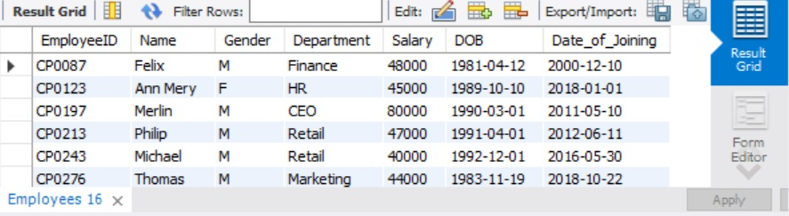

1. Write SQL queries to select employees from the following departments
   1. Marketing

SELECT * FROM Employees WHERE Department = 'Marketing';

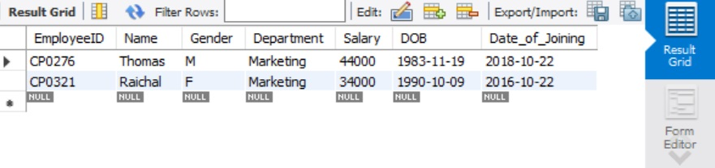

* 1. Retail

SELECT * FROM Employees WHERE Department = 'Retail';

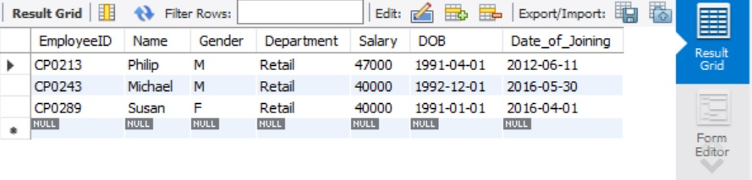

* 1. HR

SELECT * FROM Employees WHERE Department = 'HR';

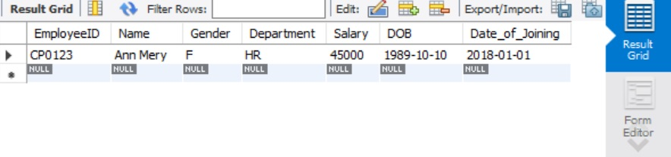

1. Write SQL queries to create a table only containing female employees.

CREATE TABLE Female_Employees as

(SELECT * FROM Employees WHERE Gender = 'F');

– Display the Structure of the table –

DESCRIBE Female_Employees;

1. 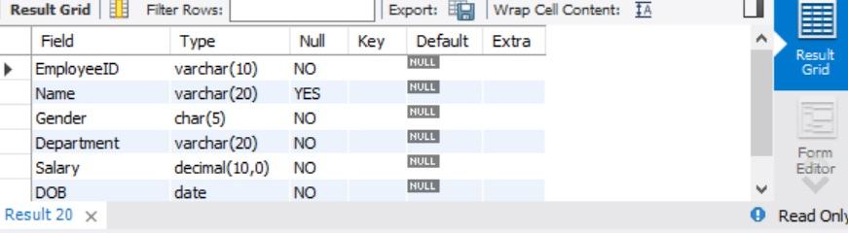

– Display the table all values –

SELECT * FROM Female_Employees ;

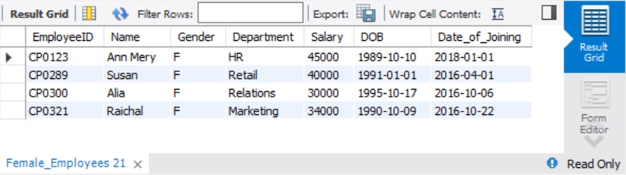

1. Write SQL queries to display the Maximum,Minimum and Average Salary.

SELECT MAX(Salary) as Maximum_Salary,

MIN(Salary) as Minimum_Salary,

AVG(Salary) as Average_Salary

FROM Employees;

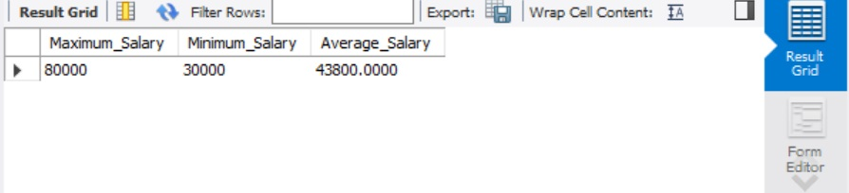

1. Write SQL query to display the employee details based on the following conditions.
   1. Male employees having salary greater than 40000

SELECT * FROM Employees WHERE Salary > 40000 and Gender="M";

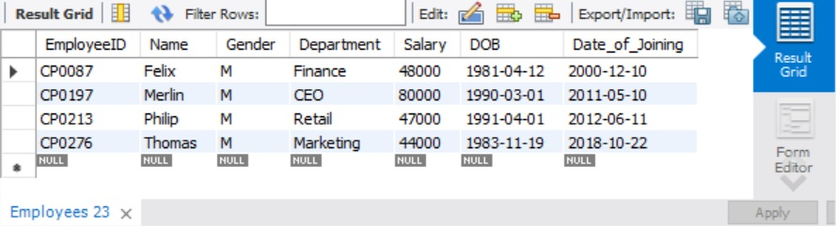

* 1. Female employees having salary less than 45000

SELECT * FROM Employees WHERE Salary < 45000 and Gender="F";

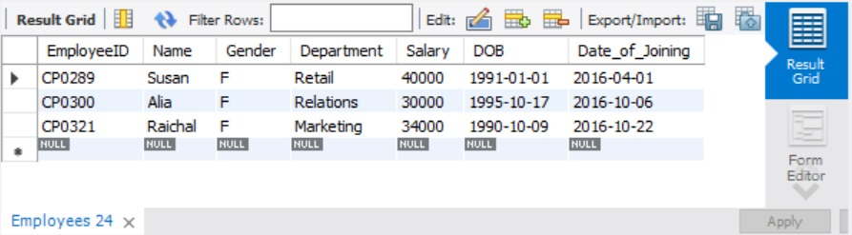

* 1. Employee having salary between 30000 and 60000 and working in Marketing or Retail department.

SELECT * from Employees WHERE (Salary BETWEEN 30000 AND 60000) AND (Department='Marketing' or Department='Retail');

